3. External morphology

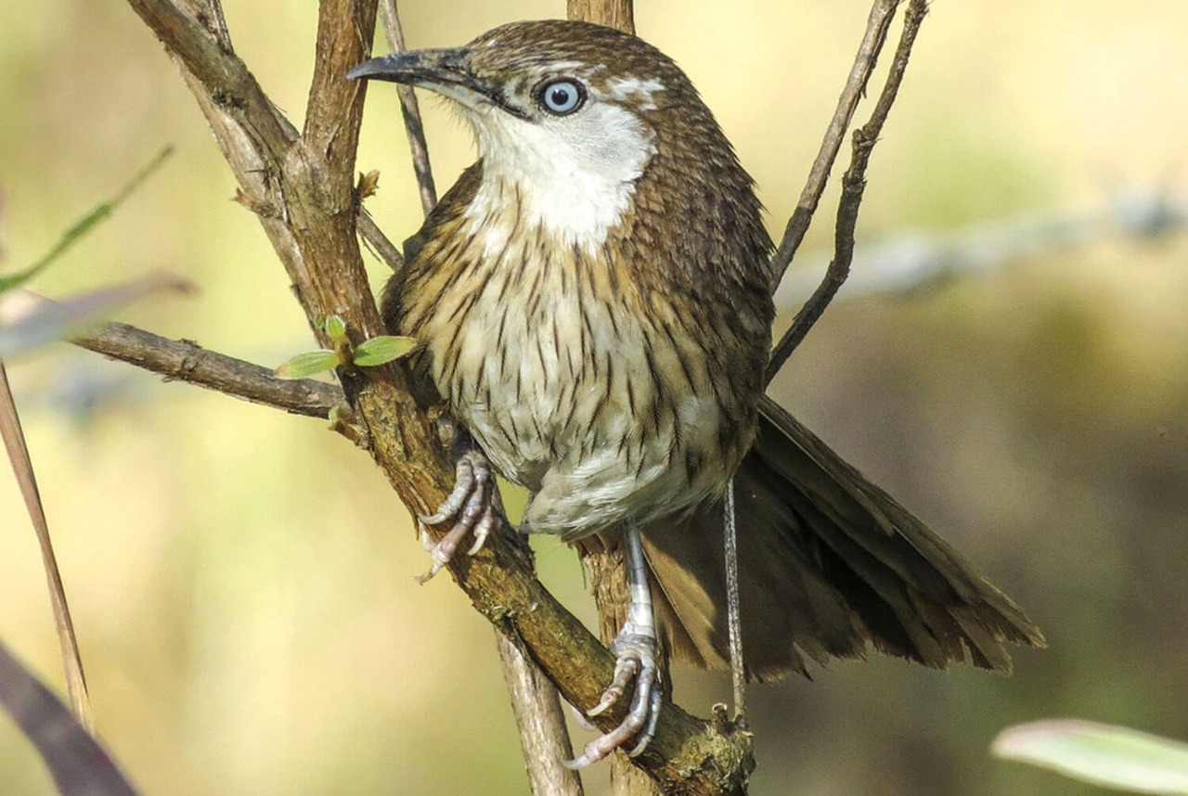

3.1 Measurements

* Length about 250 to 260mm
* Tail about 125 to 130
* Wings 85 to 90mm
* Tarsus about 30nm
* Cullman about 18 to 19mm

Its body is streamlined and is divisible into head, neck, trunk, and tail. Head is small and round, eyes are large, spherical and movable eyelids, pupil, rounded and nictitating membrane well developed. Jaws are modified into a beak. Teeth are absent in a beak but at the base of upper beak are two nostrils. Entire body surface except feet is covered with feathers. The feathers provide, insulation, thereby preventing the loss of heat and maintaining a constant temperature of the body. The flight muscles are well developed, which power the downward and upward motion of wings. Forelimbs are modified into wings containing flight features called remiges. Hind limbs are adapted for perching ability to rest on the trees which are supposed to be safer than ground. Each leg has four movable toe, three toes forward and one toe backwardly directed. A cloacal aperture is present between trunk and tail. Sexes separate. Female has only one functional ovary (egg). It reduces its weight.

3.2 PLUMAGE

The whole upper plumage, tail and visible portions of the wings are rich olive brown in color. The feathers of the head and back are provided with stiff, black shaft. Tail is cross-rayed darker. Lore’s and the feather behind and below the eyes are whitish. The ear-coverts are brown, mixed with white. The lower plumage is rufescent. Each feather is dark brown shaft-stripe, these increasing in size on the breast and abdomen. The undertail coverts and flanks are plain rufescent brown.

The colors of soft part-bill dusky horn; legs fleshy brown, Irish smoky brown. In summer the lore’s, the feather around the eye, the ear coverts, cheek, chin and the throat become white. The shaft of the throat feathers become glistening. The lower plumage becomes whiter, especially on the abdomen. This is known as summer plumage.

The spiny babbler has two plumages: summer plumage and winter plumage. The different specimens and studied by various ornithologist like Mandelli and Pinwill shows the bird with different plumage. On examining the Hodgson’s specimens of this bird, also one procured by Captain Pinwill and one by Mandelli, there can be little doubt that spiny babbler has a summer and winter plumage. Two specimens are in the summer plumage and one of these is moulting and acquiring some rufous feathers on the throat.

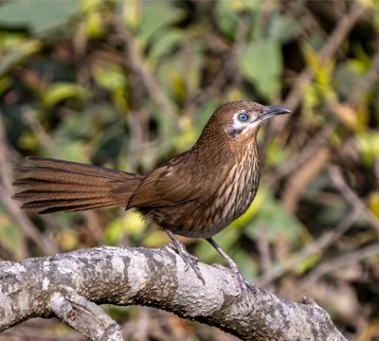

3.3 FEET

Their feet are typically small and have no feathers. They have three toes pointed forward and one-toe pointed backward. The toe arrangement is known as anisodactyl.

They have very little feeling in their feet because their feet have few nerves and blood vessels. This adaptation allows them to land on cold perches such as wires when the weather is frosty.

When they roost (settle down to rest), their belly feathers cover their feet to keep them warm. If the weather is especially cold, they will squat to cover their feet as they eat. They are able to keep their grip because perching birds have thin tendons called flexor tendons that extend from the leg muscles down the black of the tarsus bone and attached to the toes.

When a bird land on perch, these flexor tendons tighten, causing the toes to lock around the perch. It is an involuntary reflex. The tendon stays tight until the leg straightens. When the bird begins to stand up, it is legs straighten, causing the tendons to relax and the toes to unlock. This release the feet.

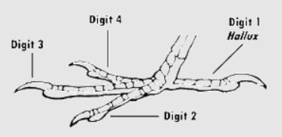

They also use their strong feet to dig out the insect from soil, perches, etc.

3.4 BEAK

The beak is short, peg like, stout and conical. This allows the bird to eat both insects as well as seed.